**Project Planning Phase**

**Project Planning Template (Product Backlog, Sprint Planning, Stories, Story points)**

|  |  |
| --- | --- |
| Date | 15 April 2025 |
| Team ID | SWTID1743870576 |
| Project Name | SpendSmart: Your Personal Finance Companion |
| Maximum Marks | 5 Marks |

**Product Backlog, Sprint Schedule, and Estimation**

| **Sprint** | **Functional Requirement (Epic)** | **User Story Number** | **User Story / Task** | **Story Points** | **Priority** | **Team Members** |
| --- | --- | --- | --- | --- | --- | --- |
| Sprint-1 | Authentication | USN-1 | As a user, I can register for the application by entering my email and password. | 2 | High | Pragni |
| Sprint-1 | Authentication | USN-2 | As a user, I can log in and log out securely. | 2 | High | Pragni |
| Sprint-1 | Authentication | USN-3 | As a user, I will receive a confirmation message after successful registration. | 1 | Medium | Pragni |
| Sprint-2 | Transaction Management | USN-4 | As a user, I can add, edit, and delete income and expense entries. | 3 | High | Vaibhav |
| Sprint-2 | Categorization | USN-5 | As a user, I can categorize transactions (e.g., Food, Travel, Rent). | 2 | High | Vaibhav |
| Sprint-2 | Dashboard | USN-6 | As a user, I can view a dashboard with my monthly and overall financial summary. | 2 | High | Ramesh |
| Sprint-3 | Visualization | USN-7 | As a user, I can view charts (pie/bar) of my income and expenses. | 2 | Medium | Chirag |
| Sprint-3 | Responsive Design | USN-8 | As a user, I can access the application on both desktop and mobile devices. | 2 | Medium | Chirag |
| Sprint-4 | Profile Management | USN-9 | As a user, I can update my profile and change my password. | 1 | Low | Ramesh |

**Project Tracker, Velocity & Burndown Chart:**

| **Sprint** | **Total Story Points** | **Duration** | **Sprint Start Date** | **Sprint End Date (Planned)** | **Story Points Completed (as on Planned End Date)** | **Sprint Release Date (Actual)** |
| --- | --- | --- | --- | --- | --- | --- |
| Sprint-1 | 5 | 5 Days | 26 March 2025 | 30 March 2025 | 5 | 30 March 2025 |
| Sprint-2 | 7 | 6 Days | 31 March 2025 | 5 Apr 2025 | 7 | 6 Apr 2025 |
| Sprint-3 | 4 | 5 Days | 6 Apr 2025 | 10 Apr 2025 | 4 | 10 Apr 2025 |
| Sprint-4 | 1 | 2 Days | 11 Apr 2025 | 12 Apr 2025 | 1 | 13 Apr 2025 |

**Velocity Calculation**

* **Sprint-1 Velocity:**5 story points / 5 days **= 1 point per day**
* **Sprint-2 Velocity:**7 story points / 6 days **= ~1.17 points per day**
* **Sprint-3 Velocity:**4 story points / 5 days **= 0.8 points per day**
* **Sprint-4 Velocity:**1 story point / 2 days **= 0.5 points per day**

**Average Velocity:** **0.94 story points/day**

**Burndown Chart:**

A burn down chart is a graphical representation of work left to do versus time. It is often used in agile[software development](https://www.visual-paradigm.com/scrum/what-is-agile-software-development/) methodologies such as [Scrum](https://www.visual-paradigm.com/scrum/scrum-in-3-minutes/). However, burn down charts can be applied to any project containing measurable progress over time.

**Burndown Chart** for the SpendSmart: Your Personal Finance Companion project. It visually shows both the **ideal progress** (dashed blue line) and your **actual progress** (green line) from 26 March to 13 April. The team is on track to complete all story points by April 13.

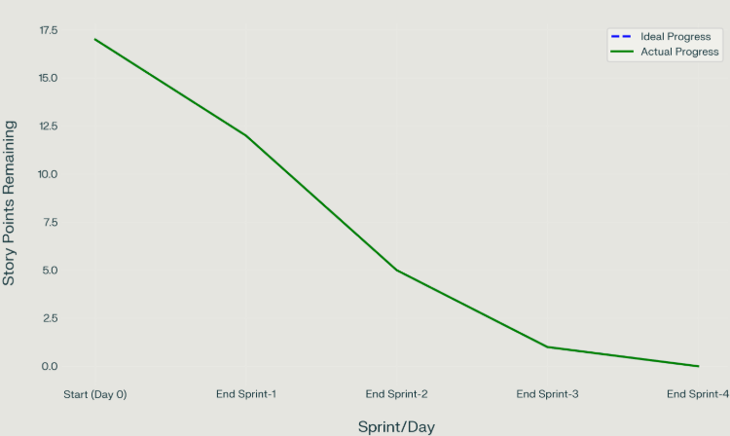

**Reference:**

[**https://www.atlassian.com/agile/project-management**](https://www.atlassian.com/agile/project-management)

[**https://www.atlassian.com/agile/tutorials/how-to-do-scrum-with-jira-software**](https://www.atlassian.com/agile/tutorials/how-to-do-scrum-with-jira-software)

[**https://www.atlassian.com/agile/tutorials/epics**](https://www.atlassian.com/agile/tutorials/epics)

[**https://www.atlassian.com/agile/tutorials/sprints**](https://www.atlassian.com/agile/tutorials/sprints)

[**https://www.atlassian.com/agile/project-management/estimation**](https://www.atlassian.com/agile/project-management/estimation)

[**https://www.atlassian.com/agile/tutorials/burndown-charts**](https://www.atlassian.com/agile/tutorials/burndown-charts)